Prepared by Dept. of Chemistry’s Safety and Compliance Sub-committee

Standard Operating Procedures (SOP) For Group Safety Representatives in Purdue’s Dept. of Chemistry

Welcome to the team
As a Purdue Chemistry Group Safety Representative (GSR), you will be responsible for maintaining a positive atmosphere of safety in your lab. This may mean sustaining the safety culture that already exists in your lab, or establishing a new safety culture. Group members will come to you with questions about everyday lab safety, updates to your lab’s Chemical Hygiene Plan (CHP), and best practices for maintaining a hazard-free lab environment. Additionally, you will work with other GSRs to improve the safety culture throughout the Chemistry department by participating in safety meetings and laboratory cross-checks.
Here you will find important information, dates, and resources that will enable you to perform your role as GSR with confidence. It is intended as an outline of responsibilities, so should be applied with your best judgment.

People to know
Here are some important people who can advise you in your role as GSR:

Paul Bower (Safety Coordinator)
    - Email: bowerp@purdue.edu
    - Location: WTHR 173
  - Alexander Wei (Chair, Departmental Safety Committee)
    - Email: alexwei@purdue.edu
    - Location: BRWN 4103D
  - Christopher West (Safety TA)
    - Email: west158@purdue.edu
    - Location: BRWN 5131

Group Safety Representative Updates
  - If the safety officer of the group changes, fill out the form below so Paul Bower can keep the GSR roster up to date. Check the list for former GSRs who have graduated or left the group, and should no longer be included in this roster.
    - Actively updated list of Group Safety Representatives: https://www.chem.purdue.edu/chemsafety/ChemSafetyCom.php

Dates/Links to remember
Here are important dates to know:

Safety Training Renewals: May 1 - May 31
    - Lab Safety Fundamentals (LSF)
https://www.chem.purdue.edu/chemsafety/Training/LSFRegistration.php
    - CHPAC (Chemical Hygiene Plan Awareness Certification)
    - PPE (Personal Protective Equipment)
https://www.chem.purdue.edu/chemsafety/Training/PPETrain/ppetonline.htm
    - BEP (Building Emergency Plan)
https://www.chem.purdue.edu/chemsafety/bep.php
  - Chemical Facility Anti-Terrorism Standards (CFATS) Chemicals Reporting: Mid May
    - https://www.purdue.edu/ehps/rem/laboratory/HazMat/Chemical%20Materials/CFATS.html
  - REM Safety Inspection of Department - June
  - Self-Audits: October 1 - October 22
    - Required Safety Postings on lab doors:
https://www.purdue.edu/ehps/rem/laboratory/researchers.html#cs2
CHP section 4.3.2
  - REM detailed discussion of forms:
https://www.purdue.edu/ehps/rem/laboratory/researchers.html#cwd2

Updating Group Safety Roster
  - Contact Paul Bower when you have a new undergraduate/postdoc/visiting scholar to have Paul add him/her to the proper lab. All of the basic safety training must be completed before the new person can obtain lab keys, and Paul will notify the safety representative or the new person if any additional training is needed.
    - Current training status: https://www.chem.purdue.edu/chemsafety/SafetyClasses.php
    - Safety training requirements can be found here for new group members https://www.chem.purdue.edu/chemsafety/Training/Training1.htm

Waste
- Forms available at: https://www.purdue.edu/ehps/rem/waste/hazwaste.html .
- All containers in need of disposal must be properly labelled before removal.
- All labels are available for free in the WTHR chemistry shop.
- Empty containers can be triple washed with a miscible, generally recognized as safe (GRAS) solvent, and then labelled with the yellow waste label (shown below), and disposed of by the janitorial staff.

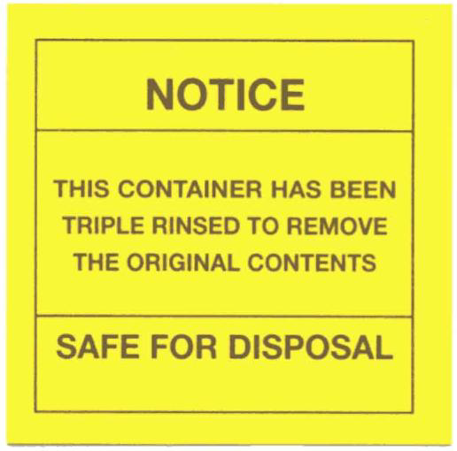
Figure 1: Safe for Disposal Label

- All chemical waste must be properly labelled and submitted as a PDF via email to hazwaste@purdue.edu.

i. Each line on the form should filled out as shown below: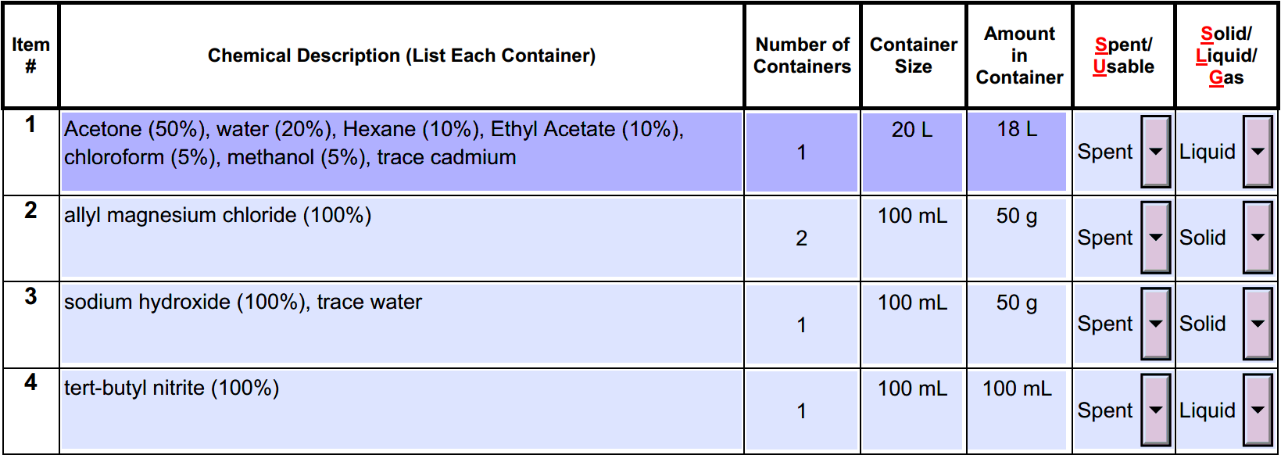
Figure 2: PDF to be submitted to hazwaste@purdue.edu

ii. The item # should be easily visible on the associated waste bottle(s).
iii. The manufacturer’s label is adequate for REM removal of any unaltered chemical waste. Do not use an orange label, unless the original label is no longer legible.
iii. Any chemical waste that differs from the manufacturer's label must be labelled with the orange waste label (shown below). The orange label on the bottle must match the form exactly, as shown below:
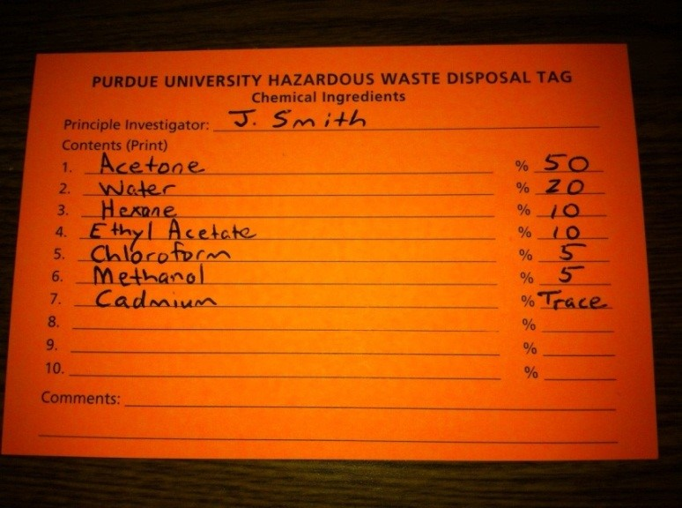
Figure 3: Purdue University Hazardous Waste Label

iv. Unknowns should be submitted as a single item # together, each with the item # visible.

- Chemical waste:
    - Wast containers should be placed in your lab’s designated area for REM removal – this is generally a waste fume hood.
    - Organize your waste for efficient removal by REM, in order of submission requests.
- Glass waste:
i. Lined cardboard containers can be purchased at Chem Stores (1st floor WTHR).
ii. All glass waste containers should be taped on the bottom; the lid should also be taped.
iii. Glass waste cannot have ANY residual chemicals; they must be rinsed before disposal.
- Sharps waste:
i. Sharps containers (hard plastic) can be purchased at Chem Stores.
ii. Sharps waste cannot have ANY residual chemicals, and must be rinsed before disposal.

Personal Protective Equipment (PPE)

PPE is required in all labs containing chemicals of any kind. The minimum PPE are required at all times in a CHP-designated space, whenever chemistry is in action: approved safety eyewear, lab coat, long clothing covering all skin below waist, and closed-toe shoes. Gloves are strongly recommended during active use of chemicals, and splash goggles may be necessary when working with large volumes or highly volatile or hazardous chemicals.
  - Rooms requiring specialized PPE (laser protection, etc.) should have signs clearly posted on the door. Note that several specialized activities require additional training provided by REM. See link for required training and re-certification. https://www.chem.purdue.edu/chemsafety/SafetyClasses.php#
  - PPE training is required/refreshed every year for each required PPE that you will use. See section 4, subsection A for dates.
  - Purchase and replacement of PPE is the PI’s responsibility. Replace your PPE as needed.
    - Basic PPE can be purchased at Chem Stores, 1st floor WTHR.
    - Safety eyewear can be purchased from any vendor. Below are links to Fisher’s inventory of glasses and goggles:
https://www.fishersci.com/us/en/products/I9C8KSYN/glasses-goggles-face-masks.html
Over-The-Glasses model (highly recommended!):
https://www.fishersci.com/shop/products/NC0593857/nc0593857#?keyword=uline+otg

Straps for safety glasses:
https://www.fishersci.com/shop/products/pyramex-spectacle-retaining-cords-6/19151638

Work-Related Injuries
  - Go to the Regional Occupational Care Center (ROCC) in Unity Healthcare Plaza, 1321 Unity Place, Lafayette, IN (off Creasy Lane, south of McCarty Lane) for follow-up care and non-emergency treatment. IF IT IS AN EMERGENCY, call 911 for an ambulance.
Urgent Care or Immediate Care Center can be contacted for serious injuries, or if the ROCC is closed (after 6 PM):
- Franciscan ExpressCare (West Lafayette): 915 Sagamore Pkwy. West
(765) 463-6262; Open daily, 8:00 AM – 8:00 PM
- Unity Immediate Care Center (same address as ROCC): 1321 Unity Pl. Suite B
(765) 446-1362; Open daily, 8:00 AM – 8:00 PM

  - For work-related injuries between 8 PM and 8 AM, the patient can be taken to one of the following EMERGENCY CARE facilities:
- IU Health Arnett (Lafayette): 5165 McCarty Lane; (765) 838-5100
- Franciscan Health Lafayette - East: 1701 South Creasy Lane; (765) 502-4000
  - All work-related injuries requiring medical attention should be reported using the First Report of Injury form. This enables REM to track and mitigate work-related hazards.
https://www.chem.purdue.edu/chemsafety/IncidentReport.php

Semi-Annual Self-Audits (May and October)
Self audits must be performed annually in May and October. This audit is to prepare for the REM audit in early June and late October.

A copy of the self-audit form can be found here:

https://www.purdue.edu/ehps/rem/documents/forms/ispcheck.pdf

If the above link is not working: Chemistry Department Website> Safety Tab> Departmental Safety Home> Safety Committee> Click: ISP Self-Audit Forms are HERE
  - Fill out the form
    - Walk around your lab to check off applicable items on the list
    - Sign the form
    - Get your PI to sign the form
    - Submit a PAPER copy to Paul Bower in WTHR 173A

Group Member Check-out
The Chemistry Department has a formal check-out procedure. Please have the group member use the link belwo, and follow instructions accordingly. The PI or GSR are requested to sign the safety check-out form, acknowledging that all action items have been carried out.
https://www.chem.purdue.edu/chemsafety/Checkout.php

